GP Referral Centre Patient Information Leaflet
Your GP has referred you to the GP Referral Centre for further assessment.

To ensure your safety and protect the health of NHS staff strict procedures are in place, please read this leaflet thoroughly before attending your appointment.

What to bring to your appointment
When attending your appointment you will need to do three things:

- Wear a mask or face covering
- Have hand sanitiser readily available in your vehicle
- Wear loose fitting clothing. This will allow the doctor who is assessing you access to your arm to perform observations such as checking your blood pressure, oxygen levels and temperature.

All clinical assessments will take place in your vehicle where possible, this is to ensure your safety.

Getting to the centre
The GP Referral Centre is based at West Heath Primary Care Centre 481 Rednal Road
Birmingham B38 8AX
The GP Referral Centre is located in the rear car park and will be signposted from the main entrance on Rednal Road. Please see below for a map.

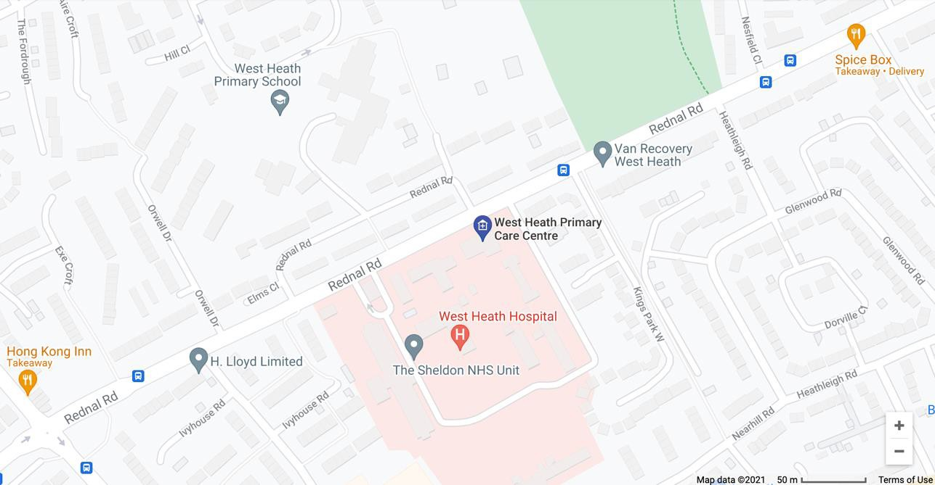

Please note that if you are able to drive a vehicle you should attend alone. If you are being driven to the GP Referral Centre you should sit in the back of the vehicle behind the driver.
Please do not use public transport to arrive at the centre as we are unable to see patients who arrive on foot. Your registered GP practice will have spoken to you about options of attending the site if you do not have your own transport.

When you arrive at the centre
Please arrive on time for your appointment, if you are late we may not be able to see you and you may have to rebook.

When you arrive please drive through the gates and park in the designated bays in the rear car park under the marquee.

You will be greeted by a Health Care Assistant who will confirm that we hold the correct information for you and check you in.

A clinician will then attend to take some basic observations.

This is a covered drive through service (see images below) so please DO NOT exit your vehicle unless you are advised to do so by a clinician.
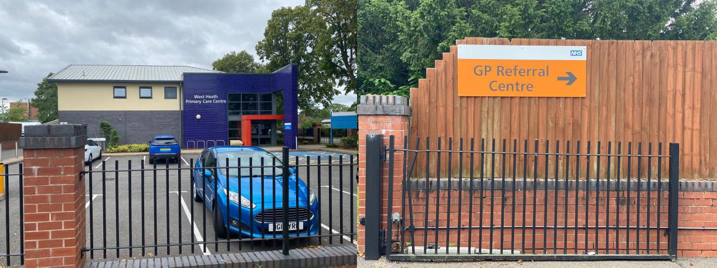
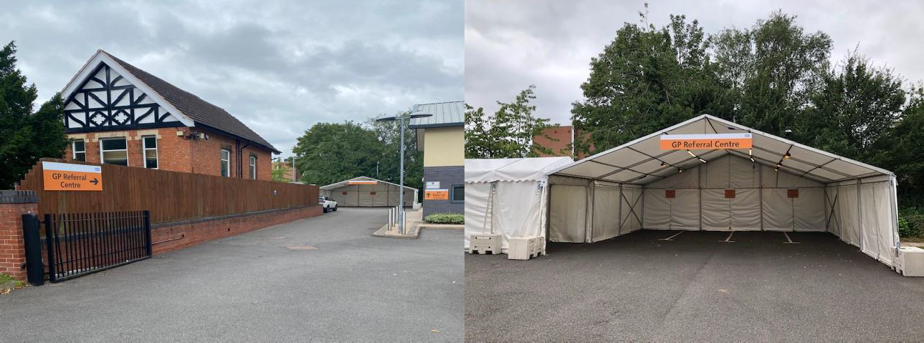

This is not a testing centre; this service will only be assessing unwell patients who have tested positive for Covid-19 or who have suspected Covid-19. Therefore it is imperative that you follow any instructions given to you by the admin and clinical staff for your own safety.

Need to change or cancel your appointment or if you have any questions.
The GP Referral Centre has a direct telephone number 0121 817 8949.

You can also contact your GP surgery who will be able to help you with any questions.

Your medical record
The GP that you see at your Referral Centre appointment will have access to your medical record as held by your registered GP.

All your data and information will be governed by the usual confidentiality and information governance policies of the NHS.

After your appointment
Once your appointment is complete the GP who has assessed you will prescribe any further treatment for you. Your registered GP will also be able to see the consultation notes following your appointment, these will be held on your medical record.
If you have any feedback on using the GP Referral Centre we would welcome your comments. You can contact Nirmal Vora, Practice Manager at West Heath Surgery.

